**Ideation Phase**

**Define the Problem Statements**

|  |  |
| --- | --- |
| Date | 27 June 2025 |
| Team ID | LTVIP2025TMID35292 |
| Project Name | **TrafficTelligence**: advanced traffic volume estimation with machine learning |
| Maximum Marks | 2 Marks |

**Customer Problem Statement Template:**

Create a problem statement to understand your customer's point of view. The Customer Problem Statement template helps you focus on what matters to create experiences people will love.

A well-articulated customer problem statement allows you and your team to find the ideal solution for the challenges your customers face. Throughout the process, you’ll also be able to empathize with your customers, which helps you better understand how they perceive your product or service.

Reference: <https://miro.com/templates/customer-problem-statement/>

**Example:**

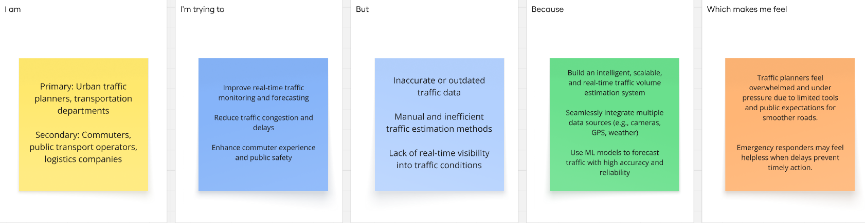

|  |  |  |  |  |  |
| --- | --- | --- | --- | --- | --- |
| **Problem Statement (PS)** | **I am (Customer)** | **I’m trying to** | **But** | **Because** | **Which makes me feel** |
| PS-1 | Traffic Planner | Improve real-time traffic monitoring and forecasting | Inaccurate and outdated data | Traffic Problems are raising | Overwhelmed and under pressure due to limited tools and public expectations for smoother roads |
| PS-2 | Public Transport operator | Optimize bus/train schedules and reduce passenger wait times | Unpredictable traffic patterns and delays | No real-time insight into road conditions or congestion | |  | | --- | |  |   Frustrated and powerless to provide timely, efficient servic |